**CHEMICAL KINETICS:
INTRODUCTION AND CLASSIFICATION**

▨ Definition and Scope
Chemical Kinetics is a major branch of chemistry that focuses on the dynamic aspect of chemical reactions. While other branches might look at the energy or structure, kinetics is specifically concerned with:
▨ Rate of Reactions: Measuring the speed or velocity at which reactants are converted into products.
▨ Factors Affecting Rates: Investigating how variables like concentration, temperature, pressure, and catalysts alter the speed of a reaction.
▨ Reaction Mechanism: Determining the step-by-step path(e.g. A → B → C → D) that molecules follow to reach the final product.
OR
The branch of chemistry, which deals with the study of reaction rates, their mechanisms and factors affecting rate of reaction, is called chemical kinetics.

▨ Classification of Reactions by Speed
Chemical reactions are categorized into three types based on their velocity:
1. Very Fast Reactions: These occur almost instantaneously, often in seconds or fractions of a second (e.g., ionic reactions).
2. Very Slow Reactions: These take a significant amount of time, ranging from days to several years (e.g., the rusting of iron or corrosion).
3. Moderate Reactions: These proceed at a measurable speed that is neither too fast nor too slow.
# is chapter m moderate reaction k bare m hi padhna h
| Kinetics Focus | Moderate Reactions | We don't study "instant" or "multi-year" reactions in this chapter. |

▨ Concept Connections
◪ Thermodynamics Link: A reaction might be highly spontaneous (very negative ΔG), but kinetically "dead" (so slow it appears not to happen). For example, the conversion of diamond to graphite is thermodynamically favored but kinetically negligible.
◪ The Limitation of Thermodynamics: Thermodynamics is a "state function" science—it only cares about the start and the finish. It is **blind to the path**. Kinetics is the study of the **actual path** (the Transition State/Activated Complex).
⛞ Kinetics = Rate + Factors + Mechanism.
⛞ Thermodynamics = Feasibility (Possibility).
◪ Mechanism Link: The study of mechanisms in kinetics is a precursor to understanding Organic Reaction Mechanisms, where the speed of steps determines the product.

▨ Common Mistakes and Traps :-
Mistake | Why Students Make It | Correct Approach / Thinking
Assuming ΔG tells the speed | They think a highly feasible reaction must be fast. | A reaction can be possible but take 100 years.
Ignoring the Mechanism | Thinking the overall balanced equation is how the reaction actually happens. | Most reactions are complex and happen in steps; the balanced equation is just the net result.

▨ RATE OF REACTION:
The Rate of Reaction (ROR) is defined as the “change in the concentration of reactants or products per unit time”. In simpler terms, it measures how fast a reactant is consumed or how fast a product is formed during a chemical process.

▨ Mathematical Expressions
# [X] == concentration of substance X.
For a general reaction: R → P
◪ Rate of Disappearance of Reactant (R):
Rate = -Δ[R]/Δt = -([R]₂ - [R]₁)/(t₂ - t₁)
* The Negative Sign: Rates cannot be negative. Since reactant concentration decreases over time ([R]₂ < [R]₁), a negative sign is added to make the final rate value positive.
◪ Rate of Appearance of Product (P):
Rate = +Δ[P]/Δt = -([P]₂ - [P]₁)/(t₂ - t₁)

▨ Stoichiometry and the Rate of Reaction
In a balanced chemical equation, the rate at which different species change may vary based on their coefficients. To find the **overall Rate of Reaction**, the individual rates must be divided by their respective stoichiometric coefficients.
◪ The Equalization Principle: Why divide by stoichiometry? If a reaction is H_2 + I_2 → 2HI, for every 1 mole of H_2 that disappears, 2 moles of HI appear. The rate of HI appearance is twice as fast. Dividing by '2' equalizes these values so we have one single "Speed of Reaction" for the entire equation.

Example: aA + bB → cC
Rate of Reaction (ROR) = -Δ[A]/(a)Δt = -Δ[B]/(b)Δt = +Δ[C]/(c)Δt

# Individual rates m aisa nahi karenge, rate of reaction m karenge-
e.g. N2 + 3H2 → 2NH3
Rate of disappearence of N2 = -Δ[N2]/Δt
Rate of disappearence of H2 = -Δ[H2]/Δt
Rate of appearence of NH3 = Δ[NH3]/Δt
Rate of reaction = -Δ[N2]/Δt = -Δ[H2]/(3)Δt = Δ[NH3]/(2)Δt
Units :
Rate= Δconcentration/Δtime = (mol litre⁻¹)/sec = mol litre⁻¹ sec⁻¹ = M sec⁻¹
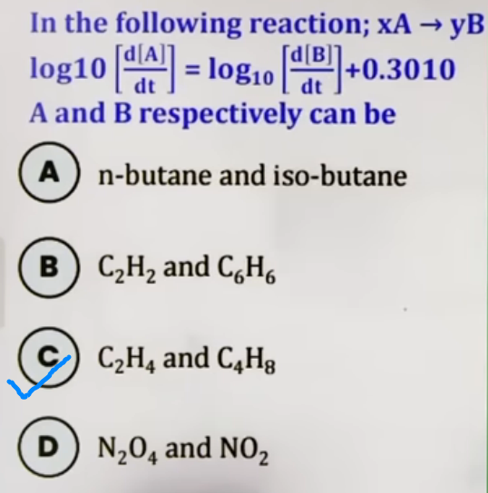
for gases-
Ideal Gas Law Link: For gases, P = (n/V)RT or P = CRT.
Rate = change in pressure/time taken = atm sec⁻¹

▨ Average vs. Instantaneous Rate
◪ Average Rate (R_{avg})
* Definition: The rate measured over a measurable/large time interval (Δt).
* Usage: Used for general laboratory observations where you measure concentration at the start and end of a period.

◪ Instantaneous Rate (R_{inst})
* Definition: The rate of reaction at a specific moment in time (t).
* Mathematical Form: Rᵢₙₛₜ = -d[R]/dt or +d[P]/dt (where Δt → 0).
* Graphical Determination: Draw a tangent to the concentration-time curve at that specific time. The slope of the tangent equals the Instantaneous Rate.

# yaha average rate se jyada kaam h, instantaneous se kam h

▨ 8. Common Mistakes and Traps
Mistake | Why Students Make It | Correct Approach / Thinking
Including coefficients in individual rates | Confusing "Rate of HI appearance" with "Rate of Reaction" | Individual rates (Appearance/Disappearance) do NOT include stoichiometric coefficients.
Time Units | Ignoring min⁻¹ vs s⁻¹ or hr⁻¹ | Always check the unit requested in the question (hr → min → s).

▨ Last-Minute Revision Points:
* R_{avg} = ΔC / Δt.
* R_{inst} = dC / dt.
* For gases: Rate unit can be atm/s.
* Reactant curve is downward; Product curve is upward.
--------------------------------------------------------------------------------

# RATE LAW/RATE EQUATION AND ORDER OF REACTION:
▨ Rate Law (Rate Equation)
The Rate Law is an experimental expression that relates the rate of a chemical reaction to the molar concentration of the reactants.
OR
Rate law is the expression in which reaction rate is given in terms of molar concentration of reatants with each term raised to some power, which may or may not be same as the stoichiometric coefficient of the reacting species in a balanced chemical equation.

For a general reaction :
aA + bB → {Products}, the rate law is expressed as:
{Rate} = k[A]ˣ[B]ʸ
◪ **x and y:** These represent the **order** with respect to reactants A and B, respectively.
◪ Crucial Note: The exponents x and y may ( in elementary reaction ) or may not be equal to the stoichiometric coefficients a and b. They are determined strictly through **experimental data**, not by looking at the balanced equation.

▨ Rate Constant (k)
Also known as the “velocity constant” or “specific rate of reaction”, k is the proportionality constant in the rate law.
◪ Specific Rate of Reaction: When the concentration of all reactants is unity (1 M), the rate of reaction is equal to the rate constant (k = Rate).
◪ Characteristics of k:
* Larger the value of k, faster is the reaction.
* For a specific reaction, k is constant at a fixed temperature.
* It is independent of the initial concentration of reactants or products.
* It changes only with temperature or the addition of a catalyst.

▨ Order of Reaction (n)
The Order of Reaction is the sum of the powers of the concentration terms in the rate law.
◪ Mathematical Definition:
If {Rate} = k[A]ˣ[B]ʸ, then -
Order w.r.t A = x
Order w.r.t B = y
Overall Order (n) = x + y
◪ Possible Values: Order can be zero, positive, negative, or fractional.
◪ Nature: It is a purely **experimental quantity**, kisi bhi rexn ko dekhkar order pata nahi kar sakte ye hamesha experimentally find kiye jata h.
◪ It is defined for both elementary as well as complex reaction.
# elementary aur complex reaction kya hote h aage likha

Unit of rate constant-
Rate = k[A]ˣ[B]ʸ
(mol litre⁻¹ sec⁻¹) = k (concentration)ˣ⁺ʸ
(mol litre⁻¹ sec⁻¹) = k ( mol litre⁻¹ )ⁿ
k = mol¹⁻ⁿ litreⁿ⁻¹ sec⁻¹

# Ye wahan kaam aayega jab hume order of reaction, n, chahiye ho are question m rate constant diya ho toh uski unit ki madad se hume order of reaction nikalne hogi ( examiner der-shana {PB})

* n = 0 (zero order rexn)
k = mol litre⁻¹ sec⁻¹
* n = 1 (first order rexn)
k = sec⁻¹
* n = 2 (second order rexn)
k = mol⁻¹ litre sec⁻¹
# kaam mainly n = 0 aur 1 m hi hoga

▨ Reaction Types
◪ I. Elementary Reactions
* These occur in a **single step**.
* For these reactions, **Order = Molecularity**.
* The Rate Law can be written directly from the balanced equation.
* Rate law is given according to law of mass action.
e.g. A + B → Product {elementary reaction}
then, Rate = k[A]¹[B]¹
order of rxn = 1+1 = 2
e.g. 2A + B → Product {elementary reaction}
then, Rate = k[A]²[B]¹
order of rxn = 2+1 = 3

◪ II. Complex Reactions
* These occur in **more than one step** (mechanism).
* The overall rate is controlled by the “Slowest Step”, known as the **Rate Determining Step (RDS)**.
A → D {Complex rxn}
intermediate steps-
A → B [ fast ]
B → C [ slow ] # RDS
C → D [ fast ]
# Ye fast, slow question m mention hoga aur koi tarika nahi pata karne ka except experimentally

* Intermediates: These are species formed in one step and consumed in another. They must be removed from the final rate law expression using equilibrium constants from fast steps.

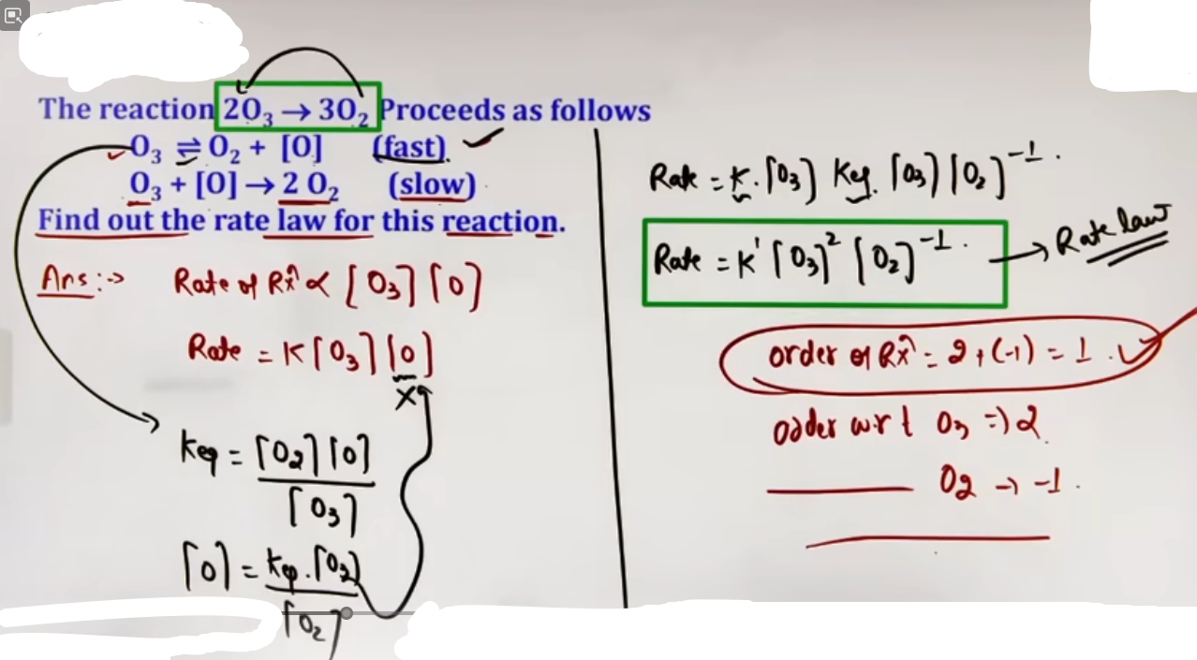

# jo reactions fast di h unhe equilibrium m manenge aur phi unka equilibrium constant nikalke uske expressions k madad se intermediates ko hatayenge substitute karke
# ek reaction slow de hogi uske alawa sare reaction fast honge aur sare fast reactions ko equilibrium m manenge,
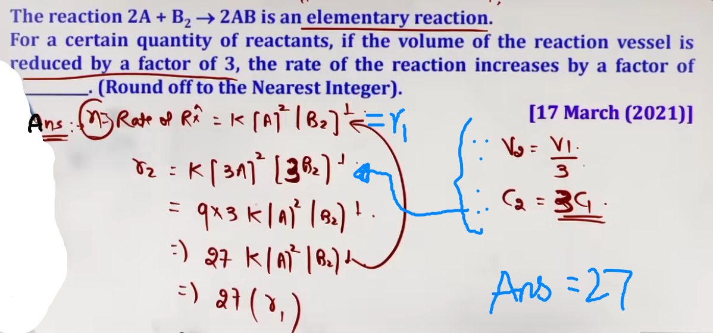
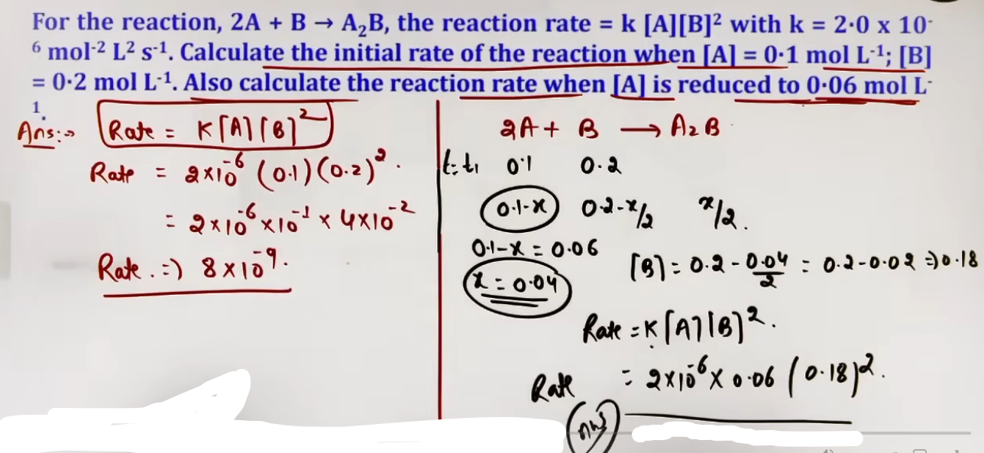

▨ Intuition and Conceptual Understanding
* The "Black Box" Analogy: Imagine a reaction as a black box. You can see what goes in (A, B) and what comes out (C), but you don't know which reactant actually "pushes" the speed. The Order tells you the sensitivity of the rate to a specific reactant.
* Why x != a usually? Most reactions are Complex, meaning they happen in multiple hidden steps. The overall balanced equation is just the net result. The Rate Law only cares about the Rate Determining Step (RDS), which is the slowest step in the mechanism.
---
▨ Formula Sheet
Concept | Formula | Key Notes
General Rate Law | Rate = k[A]ˣ[B]ʸ | x, y are experimental.
Overall Order (n) | n = x + y | Sum of exponents.
Unit of k (General) | mol¹⁻ⁿ litreⁿ⁻¹ sec⁻¹ | N = overall order
Specific Rate | k = Rate | When [A] = [B] = 1 M

▨ Problem-Solving Framework
(imp) | Finding Order from Table Data | Table with [A], [B], and Initial Rates. | Ratio Method: Keep one concentration constant and see how changing the other affects the rate. |
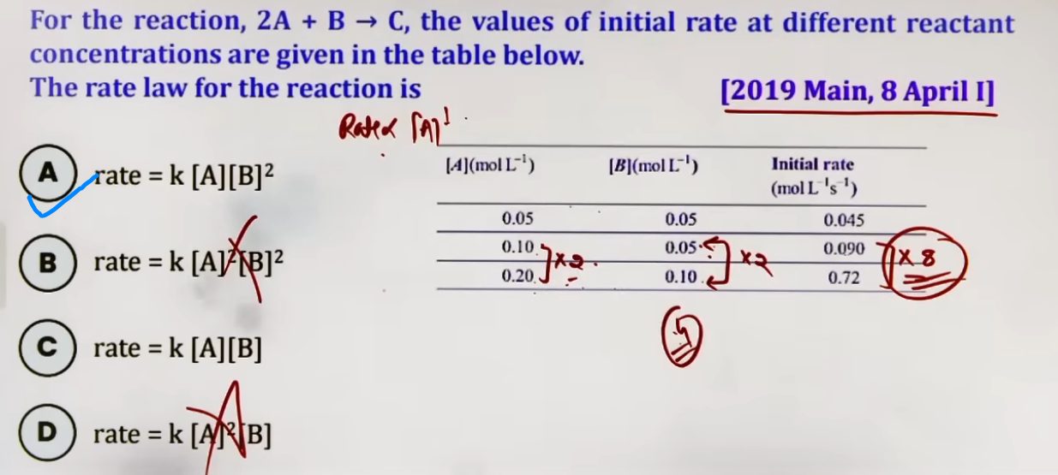
# Isme jab [A] ko double kiya 0.05 se 0.10, [b] ko same rakhte hue to rate bhi double ho gaya matlab rate∝[A]¹ aur jab [A] aur [B] dono ko double kiya toh rate 8 times ho gaya [A] ko double karne se rate 2 times hua hoga (∵ rate∝[A]¹) toh toh [B] do double karne se 4 times hua hoga net 8 times karne k liye, [B] double karne se rate 4 times badh gaya matlab rate∝[B]² ∴ option B correct

▨ JEE Advanced Insights
* The Identification Trick: In Advanced problems, the order is often hidden in the units of k. Always check the units if the order isn't explicitly mentioned.
* Fractional Orders: These are common in gaseous reactions (e.g., H_2 + Br_2 → 2HBr) and suggest a complex chain mechanism.
* Zero Order Rarity: Zero-order reactions are usually surface-catalyzed (e.g., decomposition of NH_3 on Pt) or photochemical, where the rate depends on the intensity of light, not concentration.
--------------------------------------------------------------------------------

▨ MOLECULARITY OF REACTION:
**Molecularity** is defined as the number of reacting species (atoms, ions, or molecules) taking part in an elementary reaction, which must collide simultaneously in order to bring about a chemical reaction. It represents the number of particles that "bash" together at the same time to form products.

▨ Key Features
◪ Theoretical Concept: Unlike the order of reaction, molecularity is a theoretical concept that exists on "pen and paper" and has no experimental basis.
◪ Restricted to Elementary Reactions: Molecularity is **only defined for elementary reactions** (reactions that occur in a single step). It has no significance for complex reactions.
◪ Always a Positive Integer: Molecularity must always be a whole number (1, 2, 3, etc.). It cannot be zero, negative, or a fraction.
#◪ Calculation: For an elementary reaction, the molecularity is the sum of the stoichiometric coefficients of the reactants in the balanced chemical equation.
#◪ Relation to Order: In an elementary reaction, the **Molecularity is always equal to the Order** of the reaction. ( x, y = a, b, in an elementary reaction )
#◪ . Probability Constraints
* Why Molecularity > 3 is Rare: Reactions with a molecularity greater than three are extremely rare.
* Statistical Reason: The probability of four or more molecules colliding simultaneously and with the proper orientation is statistically very small.
* Reaction Speed: Reactions that would require high molecularity are typically very slow because the chance of such an effective collision is so low.

e.g. 2A + B → C {elementary rxn}
molecularity = order = 2 + 1 = 3
If "Elementary" is mentioned, Order = Molecularity = Sum of Stoichiometric Coefficients.

▨ Difference between Molecularity and Order :-
Order | Molecularity
Order of a reaction is an experimental quantity. It can be zero and even a fraction. | Molecularity cannot be zero or a non-integer and it is a theoretical concept.
Order is applicable to elementart as well as complex reactions. | Molecularity is applicable only for elementary reactions. For complex reaction molecularity has no meaning.
For complex reaction, order is given by the slowest step. | Molecularity of the slowest step is same as the order of the overall reaction.

▨ Concept Connections
* Collision Theory Link: Molecularity is the physical manifestation of Collision Theory—it tracks the actual number of particles in a collision.
▨ JEE Advanced Insights
* In mechanism problems, the molecularity of the Rate Determining Step (RDS) (which is an elementary step) determines the overall order of the complex reaction.
* The "Elementary" Trap: If a question gives you a balanced equation like 5Br⁻¹ + BrO₃⁻¹ + 6H⁺¹ → 3Br₂ + 3H₂O, the molecularity cannot be 5+1+6=12. This is a complex reaction. Only use stoichiometry for molecularity if the word "Elementary" is explicitly stated.
* Order-Molecularity Equality: For a simple single-step reaction, the stoichiometric coefficients must be the exponents in the rate law. If they aren't, the reaction is complex by definition.
▨ High-Yield Revision Sheet
Must Remember:
* Molecularity is THEORETICAL; Order is EXPERIMENTAL.
* Molecularity is ONLY for Elementary Reactions.
* Molecularity = Order only for elementary reactions.
* Values: Molecularity is always a natural number (1, 2, 3).
* Probability barrier: n > 3 is rare due to low collision probability.
* Unimolecular/Bimolecular/Trimolecular are terms for molecularity 1, 2,and 3.
* If a rate law has a fractional power, the reaction cannot be elementary.
--------------------------------------------------------------------------------

# PSEUDO FIRST ORDER REACTIONS
A “Pseudo First Order Reaction” is a reaction that appears to be of a higher order (usually second order) based on its stoichiometry but follows first-order kinetics under specific experimental conditions.

▨ The Mechanism of "Deception"
The word "Pseudo" translates to "false" or "fake". These reactions occur when one of the reactants is present in “large excess” (often acting as a solvent).
* Because the reactant is in such high quantity, its concentration remains practically constant throughout the entire reaction.
* Since the rate of reaction depends on the change in concentration, and the excess reactant's concentration doesn't change significantly, it is removed from the active part of the rate law.
---
▨ Intuition and Conceptual Understanding
* The "Pond/Lake" Analogy: Imagine a massive lake. If you take one mug of water out of it, the overall level or "concentration" of the lake does not change in any measurable way. Similarly, in a pseudo-first-order reaction, the excess reactant is the "lake"; the reaction uses a "mug" of it, leaving the concentration virtually untouched.
* Mathematical Shift:
* If a reaction is A + B → Product, the theoretical rate law is
Rate = k'[A][B].
* If [B] is in huge excess, then [B] is a constant.
* New Rate Law: Rate = (k'[B])[A] = k[A], where k is the pseudo-first-order rate constant.
| Condition | [Excess] >> [Reactant] | Usually the solvent is in excess. |
---
▨ Examples and Applications
◪ I. Acid-Catalyzed Hydrolysis of Ethyl Acetate (Ester)
The hydrolysis of an ester in the presence of an acid is the most common example.
* Reaction: CH₃COOC₂H₅ + H₂O --(H⁺)--→ CH₃COOH + C₂H₅OH.
* Observations: Because water is the solvent and is present in large excess, its concentration does not change.
* Actual Rate Law: Rate = k[CH₃COOC₂H₅].
◪ II. Inversion of Cane Sugar (Sucrose Hydrolysis)
The process of breaking down sugar into glucose and fructose in an acidic medium.
* Reaction: C₁₂H₂₂O₁₁(Sucrose) + H₂O → C₆H₁₂O₆(Glucose) + C₆H₁₂O₆(Fructose).
* Observation: This is also called the **Inversion of Cane Sugar**. Despite having two reactants, the rate only depends on the concentration of sucrose because water is in excess.
---
▨ JEE Advanced Insights
* The "Solvent" Rule: In almost all hydrolysis reactions where water is the medium, assume pseudo-first-order kinetics unless specified otherwise.
* Molecularity vs. Order: These reactions are excellent examples of where molecularity and order differ. The molecularity is 2 (two molecules must collide), but the order is 1.
▨ Must Remember:
* Pseudo First Order = False First Order.
* Occurs when one reactant is in large excess.
* Rate Law: Rate = k[Reactant], where water/solvent is ignored.
* The concentration of the excess reactant is considered constant.
* These reactions are technically bimolecular but unimolecular in kinetics.
------------------------------------------------------------------------------------------------

# INTEGRATED RATE EQUATIONS
# most important part of the chapter
▨ I. Zero Order Reactions
* Definition: A reaction where the rate is independent of the concentration of the reactants.
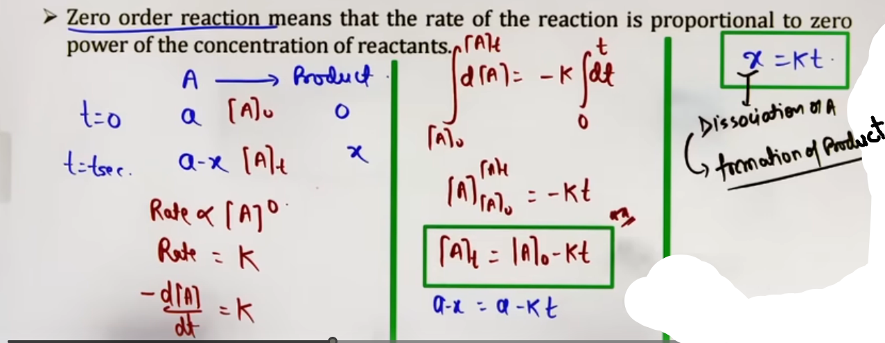
* Differential Rate Law: Rate = k[A]⁰ = k.
* Integrated Rate Equation: [A]ₜ = [A]₀ - kt.
* [A]₀: Initial concentration.
* [A]ₜ: Concentration at time t.
* Amount Dissociated (x): x = kt, where x is the concentration of product formed or reactant consumed.
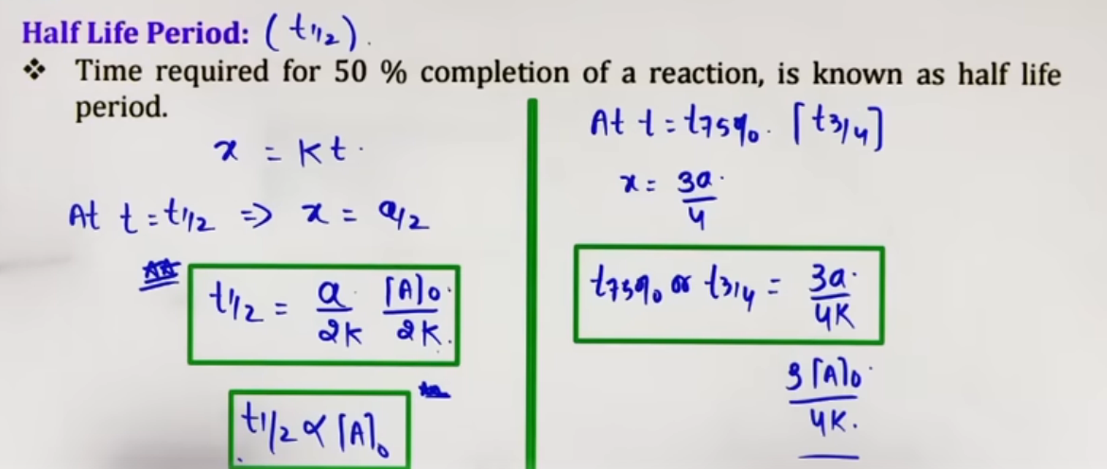
* Half-life (t_{1/2}): The time required for 50% of the reaction to complete.
* Formula: t_{1/2} = [A]₀/2k
* Observation: t_{1/2}∝[A]₀. The half-life is directly proportional to the initial concentration.
* Completion Time (t_{100}): t_{100} = [A]₀/k.
* Examples: Photochemical reactions (H_2 + Cl_2 \xrightarrow{h\nu} 2HCl) and surface-catalyzed reactions like decomposition of NH_3 on a Platinum surface.
# half life wale do uppar wale formule se likal sakte h {[A]ₜ = [A]₀ – kt} bas time t pe [A]ₜ nikalna h.
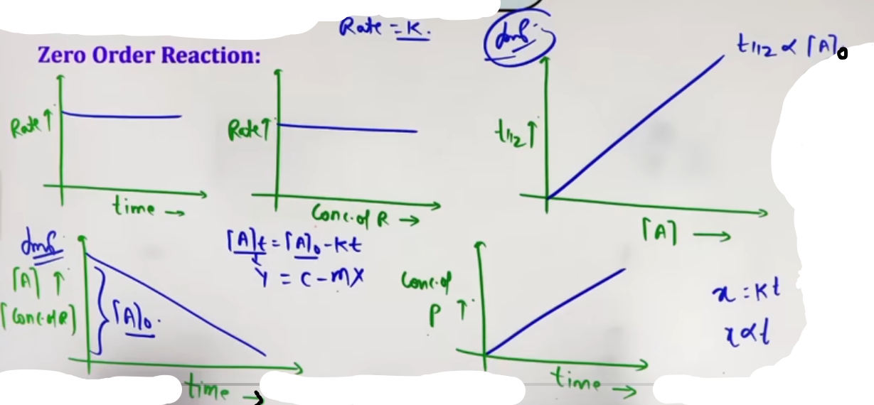

▨ II. First Order Reactions
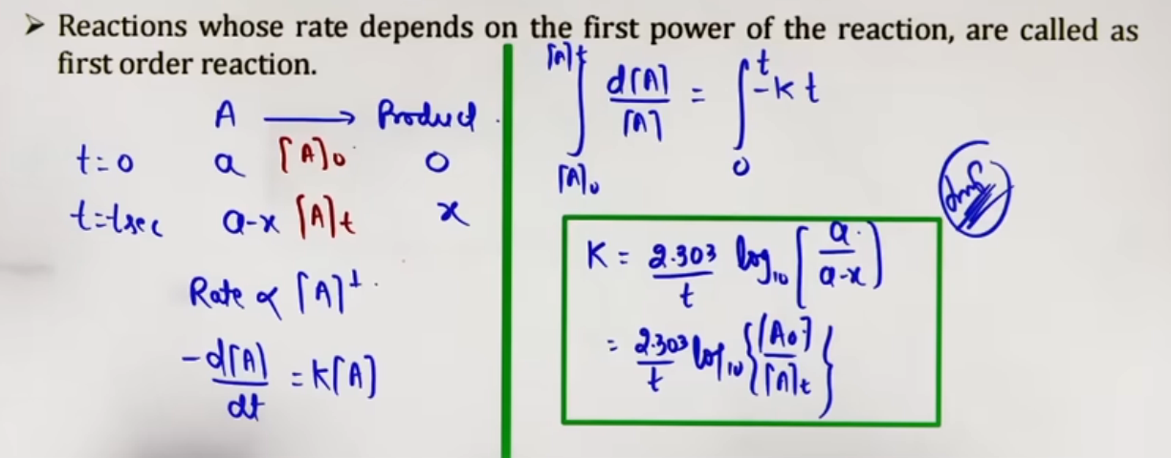
* Definition: A reaction where the rate is directly proportional to the first power of the concentration of the reactant (Rate = k[A]).
* Integrated Rate Equation:
* Logarithmic form: kt = ln{[A]₀/[A]ₜ} = (2.303)lg{[A]₀/[A]ₜ}.
* Exponential form (Wilhelmy Equation): [A]ₜ = [A]₀ e^{-kt}.

* Half-life (t_{1/2}):
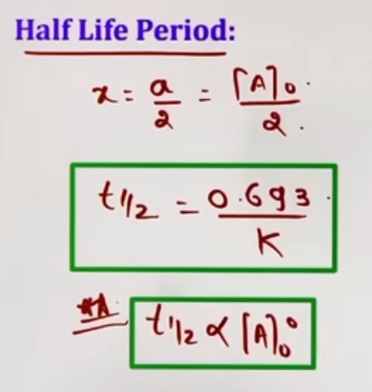
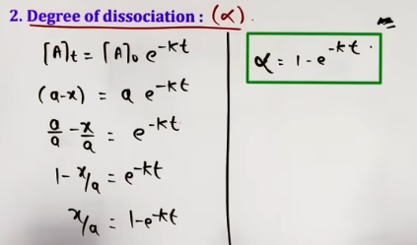
* Formula: t_{1/2} = 0.693/k.
* Crucial Property: t_{1/2} is “independent​​” of the initial concentration.
* Average Life (t_{avg}): t_{avg} = 1/k =
(1.44)(t_{1/2}).
It is the time in which 63.21% of the reactant is converted into products.
* Amount left after n half-lives: [A]ₙ = [A]₀/2ⁿ

* Degree of Dissociation (∝): ∝ = 1 – e^{-kt}.

* Examples: All radioactive decay processes, decomposition of N₂O₅, and H₂O₂.

▨ nᵗʰ Order Reactions (n >= 2)
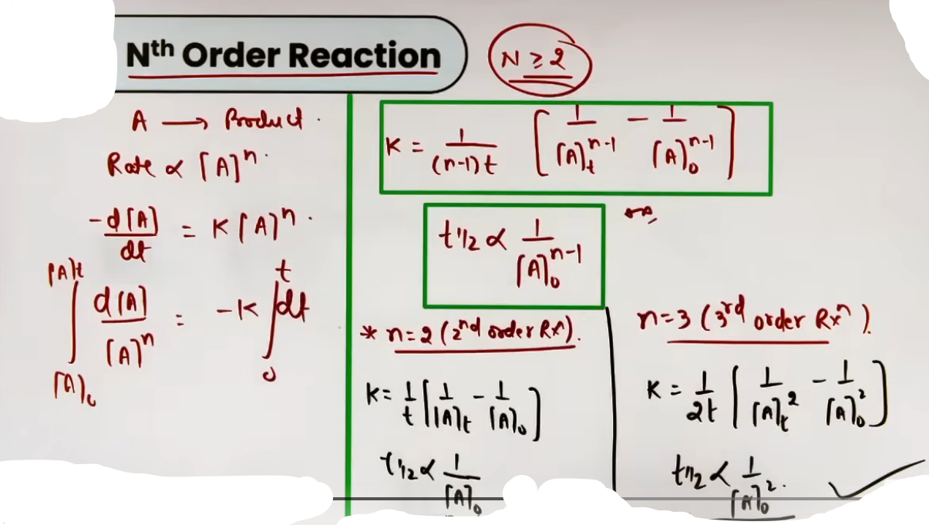
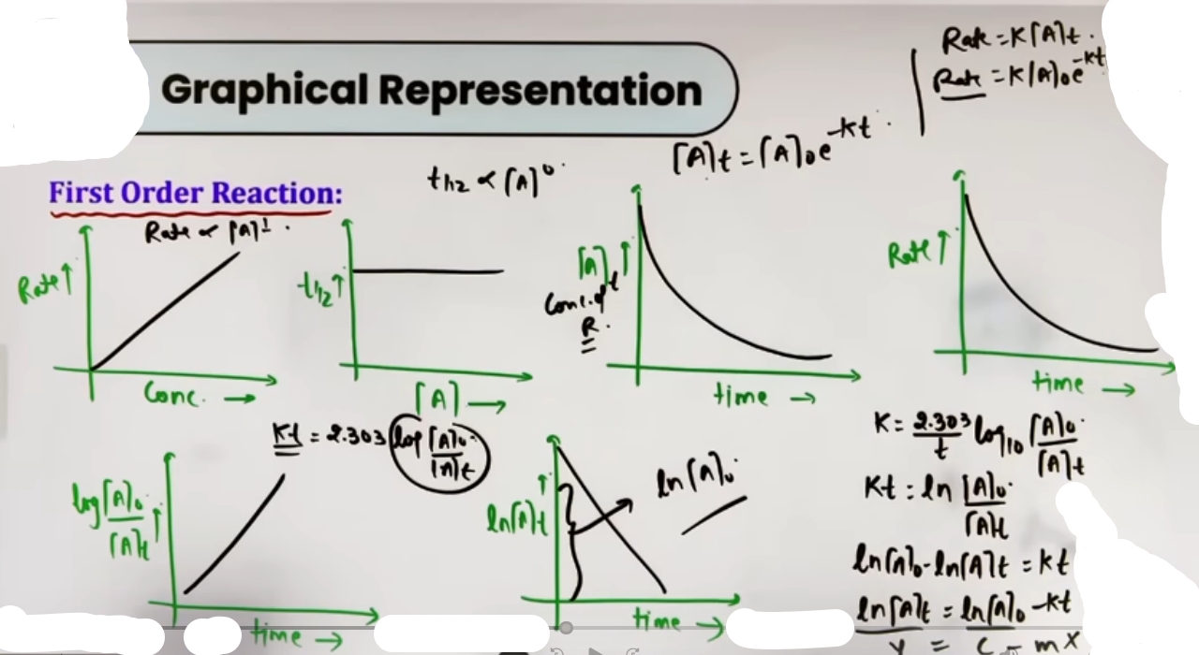
* General Integrated Law: kt = [1/(n-1)][1/[A]ₜⁿ⁻¹ - 1/[A]₀ⁿ⁻¹].
* Specific Cases:
* Second Order (n=2): kt = 1/[A]ₜ - 1/[A]₀.
* Third Order (n=3): kt = (1/2)[1/[A]ₜ² - 1/[A]₀²].
* Half-life Proportionality: t_{1/2} ∝ 1/[A]₀ⁿ⁻¹.
* For 2nd order: t_{1/2} ∝ 1/[A]₀.
* For 3rd order: t_{1/2} ∝ 1/[A]₀².
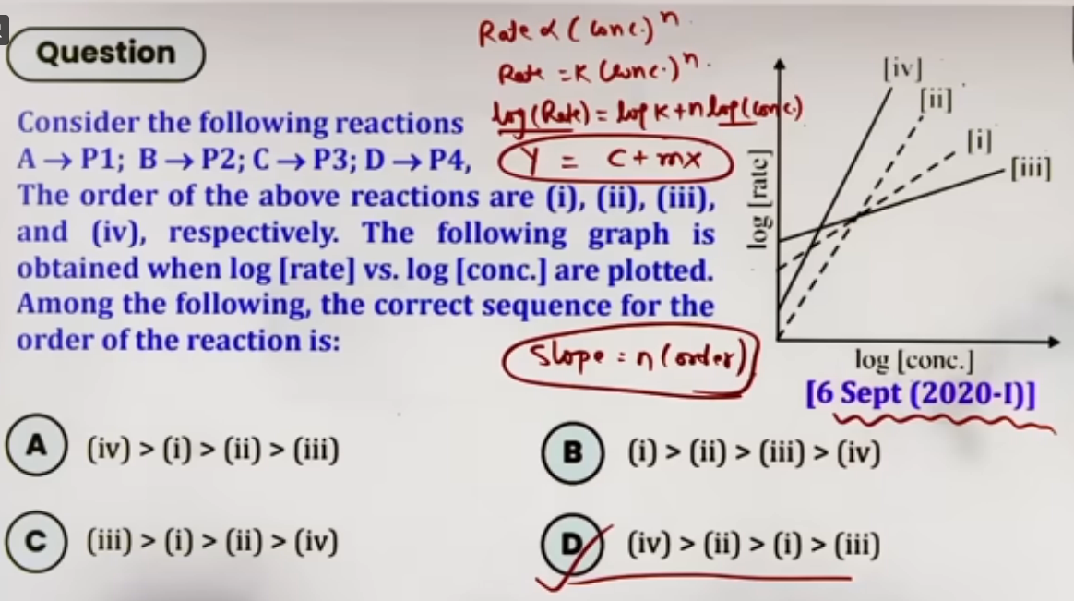
▨ Intuition and Conceptual Understanding
* Zero Order "Steady Speed": Imagine a car moving at a constant speed regardless of how much fuel is in the tank. In Zero Order, the "machinery" (like a catalyst surface) is saturated; adding more reactant doesn't speed it up.
* First Order "Proportional Decay": This is like a population where the number of deaths is a fixed percentage of the current population. As the population (concentration) decreases, the number of deaths (rate) also slows down.
* The Half-Life Constant: In first-order kinetics, it doesn't matter if you start with 100M or 1M; it will always take the same time to reduce that amount by half.
---
▨ Formula Sheet
Order | Integrated Rate Law | Half-life (t_{1/2}) | Units of k
0 | [A]ₜ = [A]₀ - kt | [A]₀/2k | mol L⁻¹ s⁻¹
1st | kt = (2.303)lg{[A]₀/[A]ₜ} | 0.693/k | s⁻¹
nᵗʰ | kt = [1/(n-1)][1/[A]ₜⁿ⁻¹ - 1/[A]₀ⁿ⁻¹] | t_{1/2} ∝ 1/[A]₀ⁿ⁻¹ | M¹⁻ⁿ s⁻¹
▨ First Order in terms of Pressure (Gaseous Reactions)
For a gaseous reaction A(g) → B(g) + C(g):
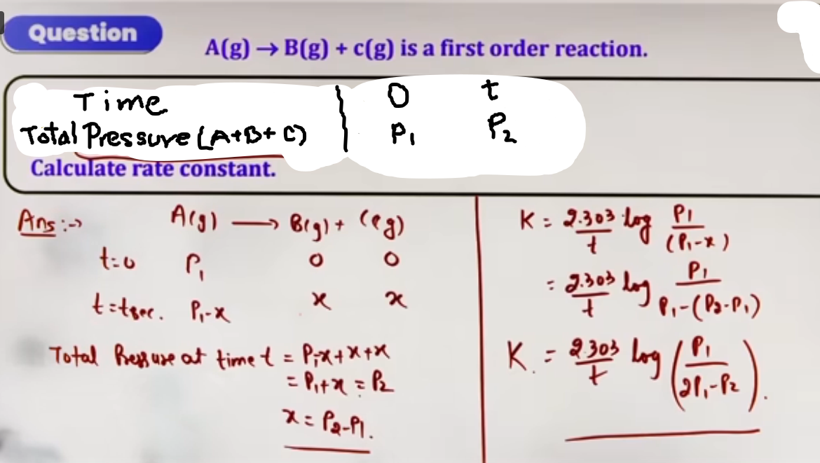
# total pressure at time = t me aaya total pressure P1 -x +x +x = P1+x par question m diya h P2 toh P1 + x = P2 yaha se x ki value nikali aur jahan chahiye wahan put kar de.

* Initial Pressure (t=0): P₁ (only for A).
* Total Pressure at time t (Pₜ): Pₜ = (P₁ - x) + x + x = P₁ + x.
* Finding x: x = Pₜ - P₁.
* Integrated Equation:
k = (2.303/t) log[P₁/(2P₁ - Pₜ)]
* Teacher's Warning: Never put P_{total} directly into the log formula. Always calculate the partial pressure of the reactant (Pₐ) at time t based on stoichiometry.
---

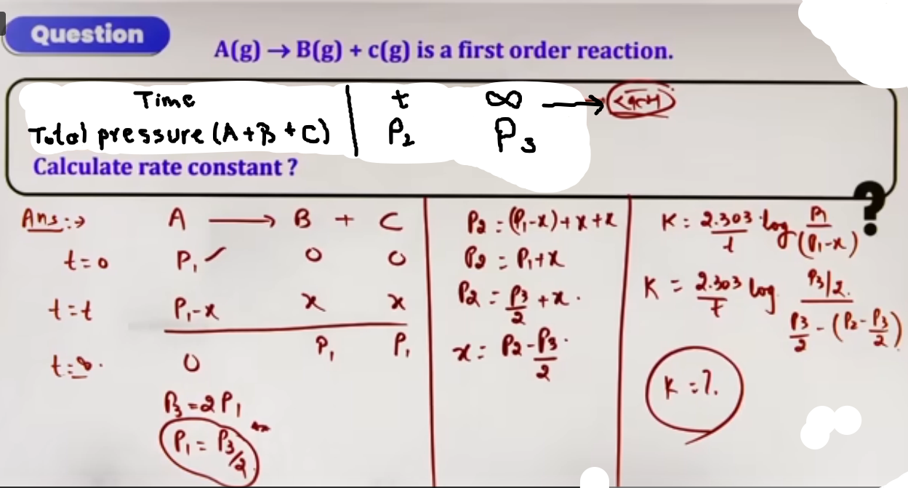
* 99.9% Shortcut: For a first-order reaction, the time required for 99.9% completion is approximately 10 times the half-life (t_{99.9\%} \approx 10 \times t_{1/2}).
▨ High-Yield Revision Sheet
Must Remember:
* 0 Order: [A]ₜ = [A]₀ - kt. Graph of [A]ₜ vs t has slope -k.
* 1st Order: k = (2.303/t)log{[A]₀/[A]ₜ}. Graph of \log[A]ₜ vs t has slope -k/2.303.
* 1st Order Pressure: k = (2.303/t)log[P_{initial}/P_{reactant at t}].
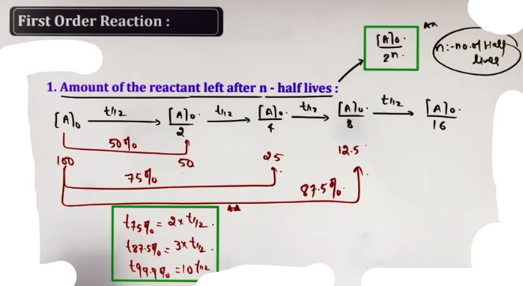
▨ Key Time Ratios (1st Order):
* t_{75\%} = 2 \times t_{50\%}.
* t_{87.5\%} = 3 \times t_{50\%}.
* t_{99.9\%} \approx 10 \times t_{50\%}.

▨ Last-Minute Revision Points:
* If a reaction goes to completion ([A]=0) in finite time, it must be Zero Order.
* First-order reactions theoretically never finish (they take infinite time for 100% completion).
* Radioactive decay follows First Order kinetics.
--------------------------------------------------------------------------------

# OTHER FACTORS AFFECTING RATE:
( isme se main sirf temperature aur catalyst h main)
▨ Nature of Reactants
The rate of a chemical reaction is significantly influenced by the chemical and physical nature of the participating species.
◪ Bonding and Polarity: Reactions involving polar reactants in polar solvents typically proceed much faster than those involving non-polar species.
◪ Chemical Specificity: Every reaction has a unique rate because the energy required to break existing bonds and form new ones is specific to the chemical nature of the reactants.
◪ Surface Area (For Solid Reactants)
In heterogeneous reactions (where reactants are in different phases, like a solid reacting with a gas/liquid), the reaction occurs only at the interface.
* Proportionality: The rate of reaction is directly proportional to the surface area of the solid reactant.
* Adsorption Link: This is highly relevant in surface-catalyzed reactions where reactant particles must accumulate (adsorb) on the solid surface to react.
◪ Effect of Catalyst
A catalyst is a substance that alters the rate of a chemical reaction without itself undergoing any permanent chemical change or change in mass.
➫ Equilibrium Influence: A catalyst does not change the equilibrium constant (K_{eq}) or the final state of equilibrium; it only helps the system reach equilibrium faster by increasing both forward and backward rates.
➫ It does not alter Gibb's energy of reaction.
➫ It does not catalyse non-spontaneous reaction.
➫ A small amount of catalyst can catalyse a large amount of reactants.
➫ It decreases the activation energy of the reaction
Eₐ ( activation energy ) of a reaction without catalyst > (Eₐ)_c ( activation energy ) of the reaction with catalyst.
log(k_c/k) = ΔE/(2.303RT), ΔE = Eₐ - (Eₐ)c

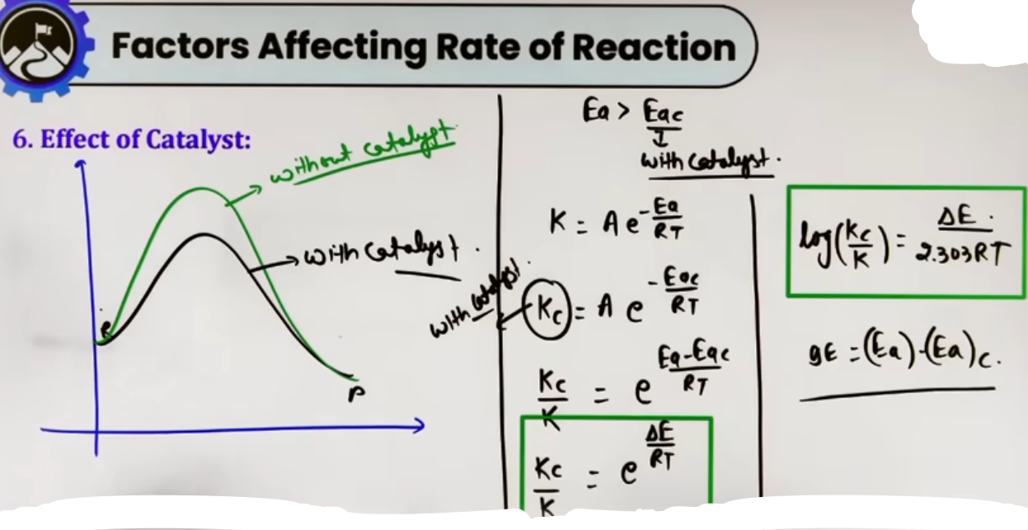
◪ Exposure to light( for photochemical rxn )
Rate ∝Intensity of light
◪ Concentration of reactants
Rate ∝(concentration)^n
◪ Temperature (v.v.imp) (agla wala ye hi h pura)
---
▨ Intuition and Conceptual Understanding
* The "Tunnel" Analogy: If the activation energy is a mountain that reactants must climb, a catalyst is like a tunnel through that mountain. It doesn't move the mountain (the enthalpy of the reaction), but it makes the journey much easier and faster for the "travelers" (molecules).
* Surface Area Visualization: Imagine a large sugar cube versus powdered sugar in water. The powder dissolves faster because more sugar molecules are exposed to the water simultaneously. In kinetics, more surface area means more "collision sites" for the reaction to occur.

▨ Concept Connections
* Thermodynamics Link: A catalyst cannot make a non-spontaneous reaction (ΔG > 0) occur; it only speeds up reactions that are already thermodynamically feasible (ΔG < 0).
* Enzymes: In biological systems, enzymes act as “bio-catalysts” lowering activation energy for metabolic reactions.
---
▨ JEE Advanced Insights
* Equal Lowering of Eₐ: A catalyst lowers the activation energy for both the forward and backward reactions by the exact same amount. Therefore, the enthalpy change (ΔH) of the reaction remains unchanged.
* Reaction Path Change: It is vital to understand that a catalyst doesn't just "lower" the existing energy barrier; it provides a completely different mechanism (alternative path) with its own transition state.
* Nature of Solvents: For Advanced-level organic kinetics, remember that the rate is significantly affected by the dielectric constant of the solvent if the reactants are polar.

▨ High-Yield Revision Sheet
Must Remember:
* Catalyst: Lowers Eₐ → Increases k → Increases Rate.
* No Effect: Catalyst does NOT change ΔG, ΔH, or K_{eq}.
* Surface Area: Finely divided solids react faster than large chunks.
* Nature: Polar-Polar interactions are generally faster.
--------------------------------------------------------------------------------

# TEMPERATURE DEPENDENCE AND ARRHENIUS EQUATION
▨ Temperature Dependence of Rate
It is a fundamental observation in chemical kinetics that the “rate of reaction increases with an increase in temperature”. This is because the rate constant (k) is highly sensitive to temperature changes.

▨ Temperature Coefficient (μ)
For many reactions, it has been experimentally found that a 10°C (or 10 K) rise in temperature causes the rate constant to approximately double or triple.
* Definition: The ratio of rate constants at two temperatures differing by 10°C.
* Mathematical Expression:
μ = k_{T+10}/k_T ≅ 2 to 3
* General Formula for any ΔT:
k_{T_2}/k_{T_1} = μ^{ΔT/10}

▨ Arrhenius Equation
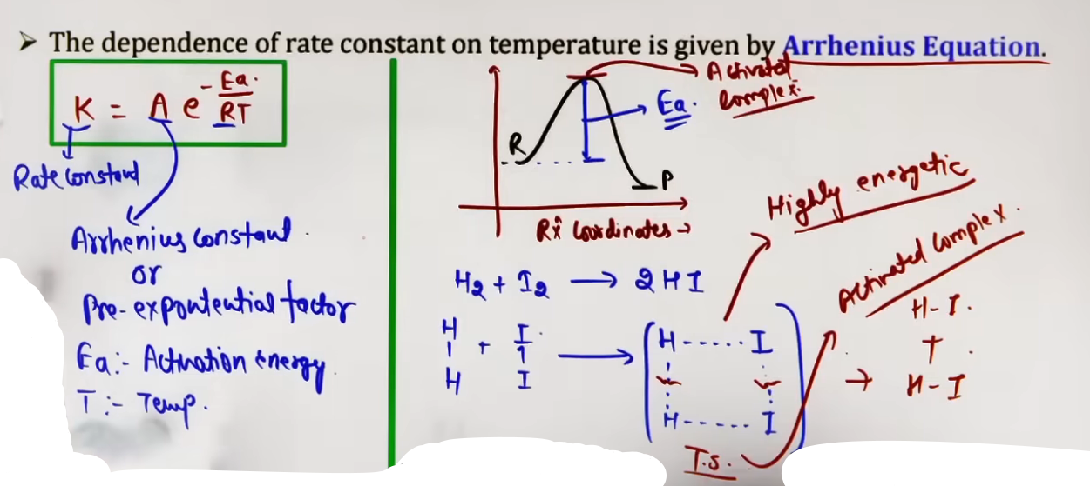
This equation provides the exact quantitative relationship between the rate constant and temperature.
* Expression: k = A e^{-Eₐ/RT}
* k: Rate constant.
* A: Arrhenius constant, Pre-exponential factor, or Frequency Factor.
* Eₐ: Activation Energy.
* R: Gas constant (8.314 JK⁻¹mol⁻¹).
* T: Absolute temperature (in Kelvin).
* Exponential term (e^{-Eₐ/RT}): Represents the “fraction of molecules” having kinetic energy equal to or greater than the activation energy (Eₐ).
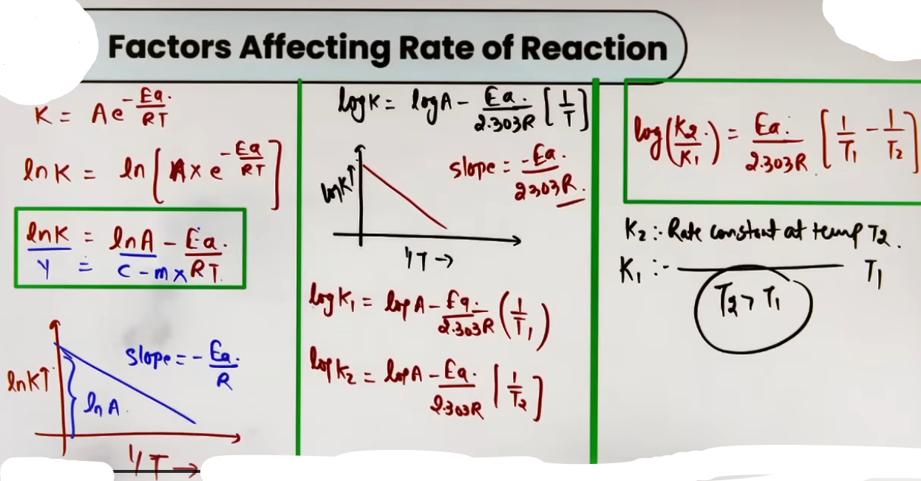
▨ Activation Energy (Eₐ)
* Definition: The minimum extra energy required by reactant molecules to cross the energy barrier and form products.
* Activated Complex (Transition State): An unstable, high-energy intermediate state formed during the collision where bonds are simultaneously breaking and forming.
* Threshold Energy (Eₜ): The total minimum energy molecules must possess to react.
Eₜ = E_{reactant} + Eₐ
▨ Intuition and Conceptual Understanding
* The "Mountain Barrier" Analogy: Imagine reactants as travelers who need to reach a valley (products) but must climb over a high mountain (Eₐ) first.
* Increasing temperature gives travelers more "stamina" (kinetic energy) to cross the peak.
* A catalyst works like a "tunnel" through the mountain, providing a path with a lower peak.
* Why does k increase exponentially? Temperature increases the average kinetic energy, but more importantly, it drastically increases the fraction of molecules in the "high-energy tail" of the distribution that can overcome Eₐ.

▨ Formula Sheet
Concept | Formula | Notes
Arrhenius (Exponential) | k = A e^{-Eₐ/RT} | Units of A = Units of k.
Arrhenius (Natural Log) | ln(k) = ln(A) - Eₐ/RT | Used for ln(k) vs 1/T plots.
Arrhenius (Base-10 Log) | log(k) = log(A) - Eₐ/(2.303RT) | Standard for calculation.
Two-Temperature Form | log(k₂/k₁) = (Eₐ/2.303R)[1/T₁ – 1/T₂] , T₂>T₁ | Relates k change to Eₐ.
Enthalpy Relation | ΔH = Eₐ{fwd} - Eₐ{back} | For reversible reactions.

▨ Concept Connections
* Thermodynamics Link: While k depends on Eₐ (kinetics), the difference between forward and backward Eₐ determines the ΔH (enthalpy) of the reaction.
* Endothermic: Eₐ{fwd} > Eₐ{back}.
* Exothermic: Eₐ{fwd} < Eₐ{back}.
* Catalysis Link: A catalyst speeds up the reaction by lowering the Eₐ, thereby increasing the value of k according to the Arrhenius equation.
▨ JEE Advanced Insights
* Temperature-Independent Eₐ: In JEE, we assume Eₐ and A are constant over small temperature ranges. However, k always varies exponentially with T.
* Sign of Eₐ: Eₐ is always positive for elementary reactions. A high Eₐ means a reaction is very sensitive to temperature changes.
* Units Warning: In the formula Eₐ/RT, ensure Eₐ and R have compatible units (both in Joules or both in kiloJoules).
Don’t use R=0.0821. For energy equations, use R = 8.314J/(K mol).

▨ High-Yield Revision Sheet
Must Remember:
* Arrhenius Eq: k = A e^{-Eₐ/RT}.
* Temp Coefficient: Rate doubles/triples per 10°C rise.
* Eₐ: Higher Eₐ = Slower reaction.
* A is called the Frequency Factor.
* e^{-Eₐ/RT} is the fraction of effective collisions.
--------------------------------------------------------------------------------

# COLLISION THEORY OF CHEMICAL REACTIONS
▨ Core Concept
Collision Theory is based on the kinetic theory of gases and posits that chemical reactions occur as a result of collisions between reactant molecules. However, simply bumping into each other is not enough; for a reaction to result in product formation, the collisions must be "effective collisions".

▨ Collision Frequency (Z)
* Definition: The number of collisions taking place per unit volume per unit time in a reaction mixture is known as Collision Frequency (Z).
* Significance: It represents the total "collision opportunities" available in the system.
* Initial Mathematical Model: When only collision frequency is considered, the rate is expressed as:
Rate = Z e^{-Eₐ/RT}.

▨ Criteria for Effective Collisions
According to the theory, only a small fraction of total collisions actually result in a chemical change. For a collision to be effective, it must overcome two major barriers:

◪ I. Energy Barrier
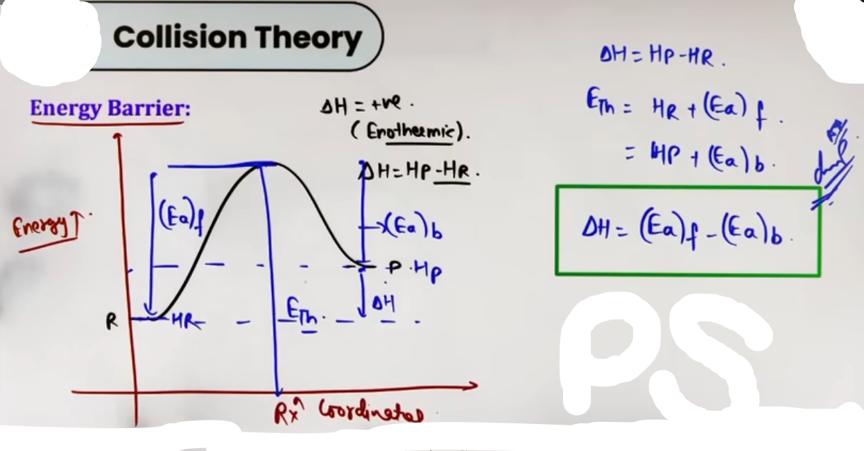
# (Eₐ)_f is the activation energy of the forward reaction.
# (Eₐ)_b is the activation energy of the backward reaction.

* Threshold Energy (Eₜₕ): Minimum amount of energy which the colliding molecules must possess in order to make the chemical reaction to occur.
* Activation Energy (Eₐ): Most molecules have a base energy (Enthalpy of Reactant, H_R); the extra energy they need to reach the threshold is the Activation Energy.
NOTE: The activation energy depends on the nature of chemical bonds undergoing rupture and is independent of reactants and products.
* Formula: Eₜₕ = H_{reactant} + Eₐ.
* Effective Fraction: The term e^{-Eₐ/RT} in the rate equation represents the fraction of molecules that have kinetic energy equal to or greater than Eₐ.

◪ II. Orientation Barrier
* Concept: Even if molecules have sufficient energy, they must collide in a specific spatial arrangement so that the existing bonds can break and new bonds can form.
* Proper vs. Improper Orientation: If molecules collide at the wrong angle, they simply bounce off each other without reacting.
K = p(Z) e^(-Eₐ/RT)
▨ Steric Factor (p)
* Definition: To account for the orientation requirement, a probability factor called the Steric Factor (p) is introduced.
* Physical Meaning: p represents the probability that molecules colliding with sufficient energy also have the correct orientation.
* Value: For most reactions, p is less than 1.
# A = p(Z), after comparing

▨ Intuition and Conceptual Understanding
* The "Lock and Key" Collision: Think of a reaction like trying to open a door. The “Energy Barrier” is having enough strength to turn the key. The “Orientation Barrier” is ensuring the key is actually inserted into the lock the right way. If you have the strength but the key is upside down, the door won't open.
* The "Crowded Room" (Z): Collision Frequency (Z) is like the number of people bumping into each other in a crowded room. The more people (concentration) and the faster they move (temperature), the higher the Z.

▨ Formula Sheet
Concept | Formula | Key Notes
Modified Rate Law | k = p(Z)e^{-Eₐ/RT} | Includes orientation (p) and frequency (Z).
Arrhenius Comparison | A = p Z | The frequency factor (A) is equivalent to pZ.
Threshold Energy | Eₜₕ = H_R + Eₐ | Total energy required.
Effective Fraction | f = e^{-Eₐ/RT} | Unitless fraction of successful collisions.
Enthalpy Change | ΔH = Eₐ{fwd} - Eₐ{back} | Energy difference between fwd and back activation.

▨ JEE Advanced Insights
* Unitless Fraction: Remember that e^{-Eₐ/RT} is a fraction of collisions, so it is unitless. Consequently, the units of the frequency factor (A) or pZ must be identical to the units of the rate constant (k).
* Endothermic vs. Exothermic Barriers:
* Endothermic: Eₐ{fwd} > Eₐ{back}, so ΔH is positive.
* Exothermic: Eₐ{back} > Eₐ{fwd}, so ΔH is negative.

▨ High-Yield Revision Sheet
Must Remember:
* Effective Collision = Energy Barrier + Orientation Barrier.
* Z (Collision Frequency): Total collisions per unit volume/time.
* p (Steric Factor): Probability of correct orientation.
* e^{-Eₐ/RT}: Fraction of molecules capable of reacting.

Key Energy Relations:
* Threshold (Eₜₕ) is the summit of the energy mountain.
* Activation (Eₐ) is the climb from the reactant's base camp to the summit.
* ΔH = E_{a(fwd)} - E_{a(back)}.
--------------------------------------------------------------------------------

# SPECIALIZED KINETICS AND CATALYSIS:(less imp)
▨ I. Parallel (Competing) Reactions
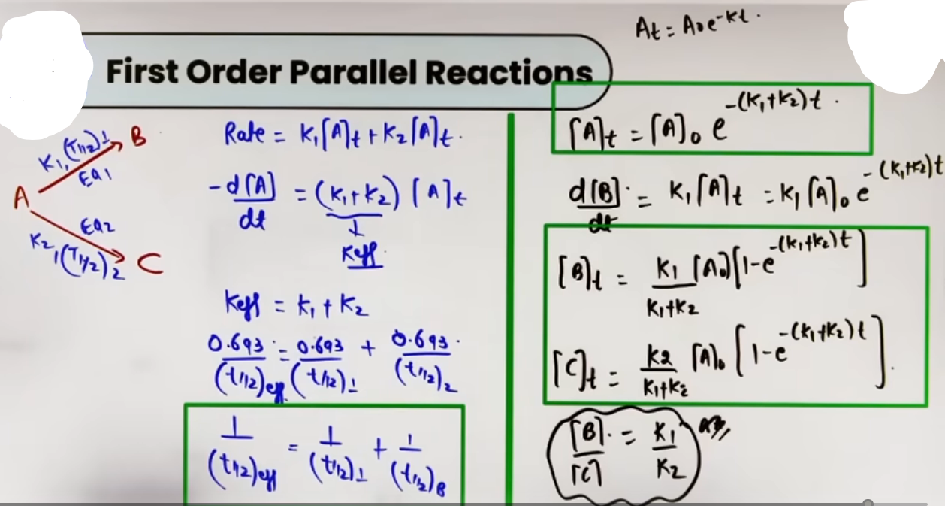
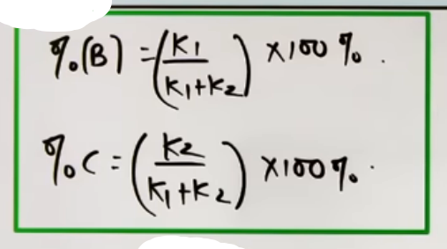
# Itne lambe chaure expresion yaad rakhne se accha method dhyan m rakhna h, K_eff dono K ka sum hoga aur rate = k[A] {for first order rxn} use karke rate = K1[A] + K2[A] aaya rate ko -dA/dt likha aur integrate kiya aur k_eff = k1 + k2 se t_(1/2) wali eqn aagaye aur phir baki ki eqn bhi aagayi.

* Definition: These are reactions where a single reactant (A) decomposes or reacts to form two or more different products (B and C) simultaneously via different paths.
* Mechanism:
* A →{k₁} B
* A →{k₂} C
* Effective Rate Constant (k_{eff}): The overall rate of disappearance of A is the sum of the rates of both paths:
-d[A]/dt = k₁[A] + k₂[A] = (k₁ + k₂)[A] = k_{eff}[A].
* Effective Half-life (t_{1/2, eff}): The net half-life for the disappearance of A is related to the individual path half-lives by:
1/t_{1/2, eff} = 1/t_{1/2, 1} + 1/t_{1/2, 2}.

▨ II. Sequential (Consecutive) Reactions

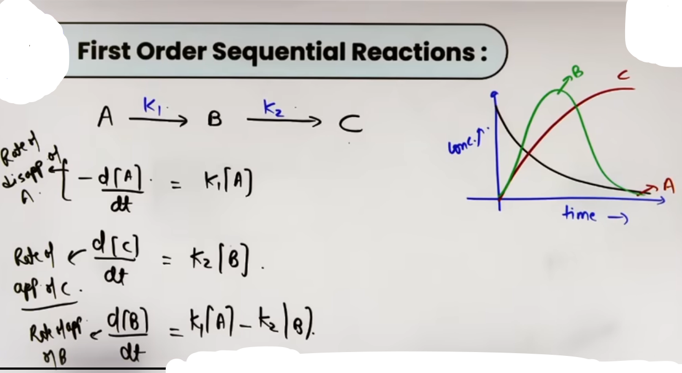
*
Definition: Reactions that proceed through one or more intermediate stages (e.g., A → B → C).
* Rate Expressions:
* For A: -d[A]/dt = k₁[A] (Standard first-order decay).
* For B (Intermediate): d[B]/dt = k₁[A] - k₂[B] (Formed from A, consumed to form C).
* For C: d[C]/dt = k₂[B].
▨ III. Reversible Reactions
* Definition: Reactions that occur in both forward and backward directions
(A ⇄ [k_b]{k_f} B).
* Net Rate: The overall rate is the difference between the forward and backward rates:
Net Rate = R_f - R_b = k_f[A] - k_b[B].
* Stoichiometric Handling: If the reaction is A ⇄ [k_b]{k_f} 2B, the power of the concentration of B in the backward rate will be 2 (for elementary reactions).
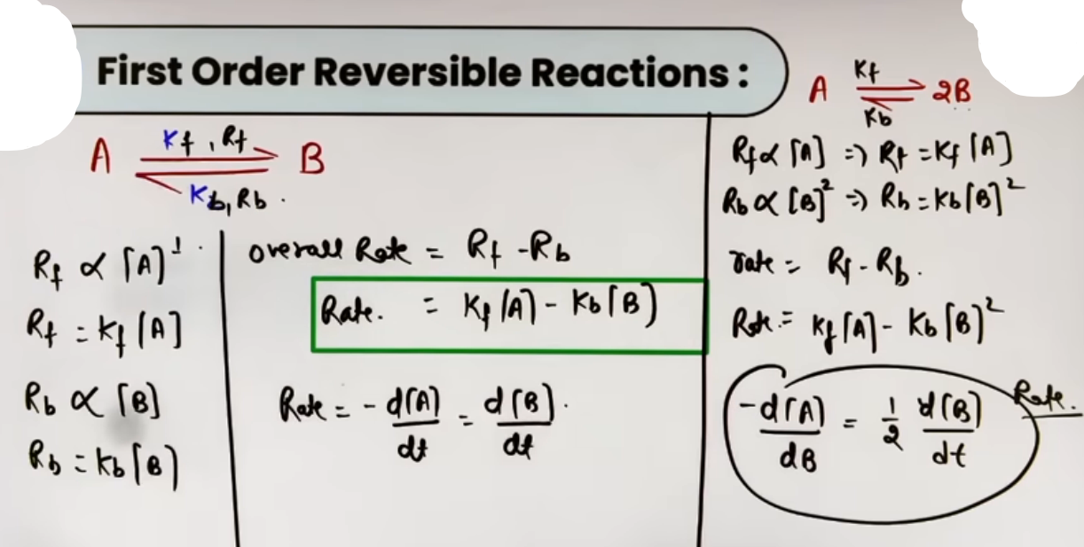
▨ Intuition and Conceptual Understanding
* Parallel Road Analogy: Imagine a reactant at a fork in the road. It can go down Path B or Path C. The "speed limit" (k) on each road determines which product forms more quickly. The total "traffic" leaving the starting point is the sum of both paths.
* Sequential "Middle Station" Model: A is the starting point, B is the middle station, and C is the destination. B starts at zero, increases as it's made from A, but eventually decreases as it's converted to C.
* Catalyst as a "Tunnel": Instead of climbing over a high energy mountain (Eₐ), the catalyst provides a tunnel (alternative mechanism) that is much lower, allowing more molecules to pass through in less time.
▨ Formula Sheet
Topic | Formula | Important Notes
Parallel k_{eff} | k_{eff} = k₁ + k₂ | k_{eff} is always larger than individual k values.
Product Ratio | [B]/[C] = k₁/k₂ | Holds true at any time t.
% Yield of B | %B = k₁(100)/(k₁ + k₂) | Calculated using rate constants.
Sequential Rate of B | d[B]/dt = k₁[A] - k₂[B] | Equals zero at the point of maximum concentration of B.
Catalyst Ratio | log(k_cat / k) | ΔEₐ = E_{a, uncatalyzed} - E_{a, catalyzed}.
▨ Concept Connections
* Radioactive Decay (Physics): Parallel kinetics is the basis for branched radioactive decay where a nucleus can decay via Alpha or Beta emission.
* Chemical Equilibrium: Reversible kinetics is the microscopic explanation for equilibrium. When R_f = R_b, the system is in equilibrium and the net rate is zero.
* Surface Chemistry: Most catalysts in JEE kinetics are heterogeneous (solids), where surface area directly influences the effectiveness of the catalyst.

▨ Examples and Applications
◪ I. Sequential Concentration Graph
* A (Reactant): Decreases exponentially from the start.
* B (Intermediate): Starts at zero, rises to a maximum, and then decays to zero.
* C (Final Product): Starts at zero and increases steadily until it reaches the initial concentration of A.

◪ II. Parallel Yield Calculation
If A \xrightarrow{k₁=4} B and A \xrightarrow{k₂=3} C, the percentage of B in the final mixture is \frac{4}{4+3} \times 100 \approx 57.1\%.

▨ High-Yield Revision Sheet
Must Remember:
* Parallel: k_{eff} = k₁ + k₂; Concentration ratio = Rate constant ratio.
* Sequential: B concentration peaks when d[B]/dt = 0; B eventually decays to zero.
* Reversible: R_{net} = k_f[A] - k_b[B]; Equilibrium means R_{net} = 0.
* Catalyst: Lowers Eₐ only; no change in stability (ΔG) or final yield (K_{eq}).

-------------------------------------------------------------------------
# Decomposition of N2O5-
2N2O5 --> 2N2O4 + O2, is a first order reaction
# For radioactive decay, decay constant does not depend upon temperature because for radioactive decay activation energy is zero.

